**1. What is Azure traffic manager?**

Microsoft Azure Traffic Manager allows you to control the distribution of user traffic for service endpoints in different datacenters. Service endpoints supported by Traffic Manager include Azure VMs, Web Apps, and cloud services. You can also use Traffic Manager with external, non-Azure endpoints

Traffic Manager uses the Domain Name System (DNS) to direct client requests to the most appropriate endpoint based on a traffic-routing method and the health of the endpoints. Traffic Manager provides a range of [traffic-routing methods](https://docs.microsoft.com/en-us/azure/traffic-manager/traffic-manager-routing-methods) and [endpoint monitoring options](https://docs.microsoft.com/en-us/azure/traffic-manager/traffic-manager-monitoring) to suit different application needs and automatic failover models

**2. How Azure traffic manager Works?**

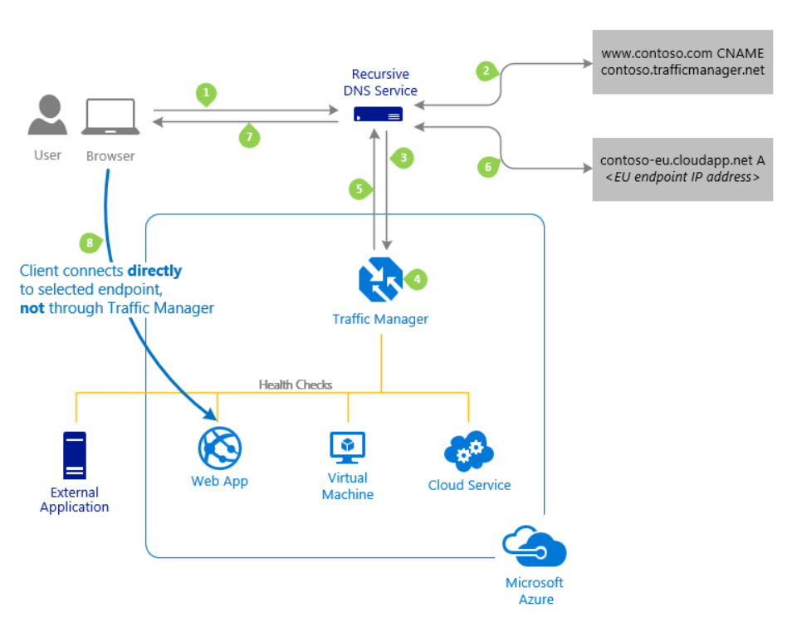

**3. What are the routing types?**

* [**Priority**](https://docs.microsoft.com/en-us/azure/traffic-manager/traffic-manager-routing-methods#priority)**:** Select **Priority** when you want to use a primary service endpoint for all traffic, and provide backups in case the primary or the backup endpoints are unavailable.(1 to 1000) 0 represents the High priority and 1000 represent the lowest priority
* [**Weighted**](https://docs.microsoft.com/en-us/azure/traffic-manager/traffic-manager-routing-methods#weighted)**:** Select **Weighted** when you want to distribute traffic across a set of endpoints, either evenly or according to weights, which you define.
* [**Performance**](https://docs.microsoft.com/en-us/azure/traffic-manager/traffic-manager-routing-methods#performance)**:** Select **Performance** when you have endpoints in different geographic locations and you want end users to use the "closest" endpoint in terms of the lowest network latency.

[**Geographic**](https://docs.microsoft.com/en-us/azure/traffic-manager/traffic-manager-routing-methods#geographic)**:** Select **Geographic** so that users are directed to specific endpoints (Azure, External, or Nested) based on which geographic location their DNS query originates from. This empowers Traffic Manager customers to enable scenarios where knowing a user’s geographic region and routing them based on that is important. Examples include complying with data sovereignty mandates, localization of content & user experience and measuring traffic from different **regions.**

**4. What is Application Gateway?**

Azure Application Gateway is an Application Delivery Controller (ADC) as a service, offering various layer 7 load balancing capabilities for your applications. It offers highly available and scalable service, which is fully managed by Azure.

* It can be configured as internet facing or internal facing
* A web application firewall (WAF) is also provided as part of the application gateway WAF SKU. It provides protection to web applications from common web vulnerabilities and exploits

**Features:**

Web application Firewall, HTTP Load balancing, Path based routing, SSL termination, Cookie based session affinity, Backend health monitoring

**5. Cookie based affinity**

The cookie-based session affinity feature is useful when you want to keep a user session on the same back-end. By using gateway-managed cookies, the Application Gateway is able to direct subsequent traffic from a user session to the same back-end for processing. This feature is important in cases where session state is saved locally on the back-end server for a user session

**6. Difference between Azure Server manager and Azure resource Group deployment model?**

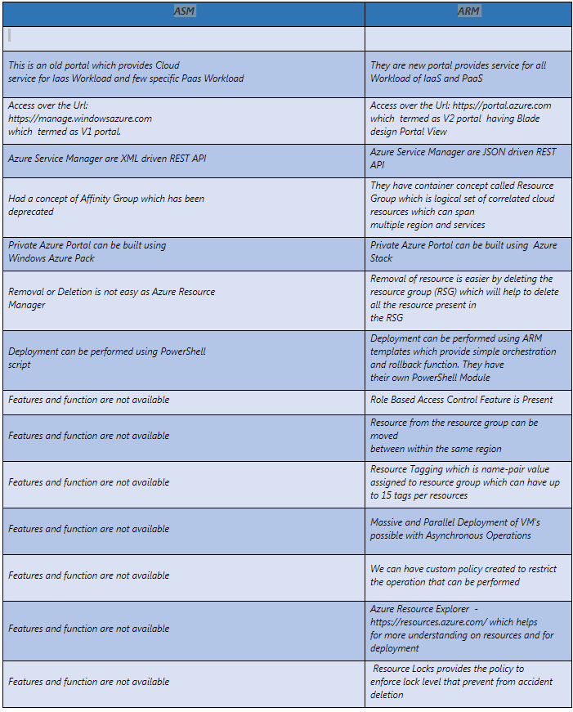

**7. How much storage can I use with a virtual machine?**

Explanation: Each data disk can be up to 1 TB. The number of data disks which you can use depends on the size of the virtual machine.

Azure Managed Disks are the new and recommended disk storage offerings for use with Azure Virtual Machines for persistent storage of data. You can use multiple Managed Disks with each Virtual Machine. Managed Disks offer two types of durable storage options: Premium and Standard Managed Disks.

Azure storage accounts can also provide storage for the operating system disk and any data disks. Each disk is a .vhd file stored as a page blob.

### 8. What are virtual machine scale sets in Azure?

**Explanation:**Virtual machine scale sets are Azure compute resource that you can use to deploy and manage a set of identical VMs. With all the VMs configured the same, scale sets are designed to support true autoscale, and no pre-provisioning of VMs is required. So it’s easier to build large-scale services that target big compute, big data, and containerized workloads

**9. What is Availability Set?**

An availability set is a logical grouping of VMs that allows Azure to understand how your application is built to provide redundancy and availability. It is recommended that two or more VMs are created within an availability set to provide for a highly available application and to meet the 99.95% Azure SLA. When a single VM is used with Azure Premium Storage, the Azure SLA applies for unplanned maintenance events.

**10. What are Fault Domains?**

A fault domain is a logical group of underlying hardware that share a common power source and network switch, similar to a rack within an on-premise data-centers. As you create VMs within an availability set, the Azure platform automatically distributes your VMs across these fault domains. This approach limits the impact of potential physical hardware failures, network outages, or power interruptions.

### 11. What are Update Domains?

### An update domain is a logical group of underlying hardware that can undergo maintenance or can be rebooted at the same time. As you create VMs within an availability set, the Azure platform automatically distributes your VMs across these update domains. This approach ensures that at least one instance of your application always remains running as the Azure platform undergoes periodic maintenance. The order of update domains being rebooted may not proceed sequentially during planned maintenance, but only one update domain is rebooted at a time

### 16. What are Network Security Groups?

**Explanation:**A network security group (NSG) contains a list of Access Control List (ACL) rules that allow or deny network traffic to subnets, NICs, or both. NSGs can be associated with either subnets or individual NICs connected to a subnet. When an NSG is associated with a subnet, the ACL rules apply to all the VMs in that subnet. In addition, traffic to an individual NIC can be restricted by associating an NSG directly to a NIC.

**17. What is VNET?**

The Microsoft Azure Virtual Network service enables Azure resources to securely communicate with other in a virtual network. A virtual network is a representation of your own network in the cloud. A virtual network is a logical isolation of the Azure cloud dedicated to your subscription. You can connect virtual networks to other virtual networks, or to your on-premises network through Virtual network Gateways.

### 18 What are the differences between Subscription Administrator and Directory Administrator?

By default, one is assigned the Subscription Administrator role when he/she signs up for Azure. A subscription admin can use either a Microsoft account or a work or school account from the directory that the Azure subscription is associated with. This role is authorized to manage services in the Azure portal. If others need to sign in and access services by using the same subscription, you can add them as co-admins.

Azure AD has a different set of admin roles to manage the directory and identity-related features. These admins will have access to various features in the Azure portal or the Azure classic portal. The admin’s role determines what they can do, like create or edit users, assign administrative roles to others, reset user passwords, manage user licenses, or manage domains.

17. What is Azure Service principal?

When you have an app or script that needs to access resources, you can set up an identity for the app and authenticate the app with its own credentials. his identity is known as a service principal. This approach enables you to:

=> Assign permissions to the app identity that are different than your own permissions. Typically, these permissions are restricted to exactly what the app needs to do.

=> Use a certificate for authentication when executing an unattended script

18. Azure storage account?

Microsoft Azure Storage is a Microsoft-managed cloud service that provides storage that is highly available, secure, durable, scalable, and redundant

Account Kind :

1. **General purpose** – Provide storage for blobs, files, tables & queues in unified account

2. **BLOB storage account** – specialized for storing blob and support choosing an access tier which allows you to specify the how frequently data in the account is accessed

**Account Types:**

**BLOB STORAGE** – Binary large object

Azure Blob storage is a service for storing large amounts of unstructured object data, such as text or binary data, that can be accessed from anywhere in the world via HTTP or HTTPS. You can use Blob storage to expose data publicly to the world, or to store application data privately

**Block blobs** are ideal for storing text or binary files, such as documents and media files.

**Append blobs**are similar to block blobs in that they are made up of blocks, but they are optimized for append operations, so they are useful for logging scenarios.

A single block blob can contain up to 50,000 blocks of up to 100 MB each, for a total size of slightly more than 4.75 TB (100 MB X 50,000).

A single append blob can contain up to 50,000 blocks of up to 4 MB each, for a total size of slightly more than 195 GB (4 MB X 50,000).

***Page blobs*** can be up to 8 TB in size, and are more efficient for frequent read/write operations. Azure Virtual Machines use page blobs as OS and data disks.

* PAGE BLOB
* APPEND BLOB
* BLOCK BLOB

**FILE STORAGE** –

URL: myaccount.file.core.windows.net

[Azure Files](https://docs.microsoft.com/en-us/azure/storage/files/storage-files-introduction) enables you to set up highly available network file shares that can be accessed by using the standard Server Message Block (SMB) protocol. That means that multiple VMs can share the same files with both read and write access. You can also read the files using the REST interface or the storage client libraries.

**QUEUE STORAGE**:

Azure Queue storage is a service for storing large numbers of messages that can be accessed from anywhere in the world via authenticated calls using HTTP or HTTPS. A single queue message can be up to 64 KB in size, and a queue can contain millions of messages, up to the total capacity limit of a storage account

URL: myaccount.queue.core.windows.net

**Blob Storage accounts**

The Blob Storage account is a specialized storage account used to store block blobs and append blobs. You can't store page blobs in these accounts, therefore you can't store VHD files. These accounts allow you to set an access tier to Hot or Cool; the tier can be changed at any time.1

The hot access tier is used for files that are accessed frequently -- you pay a higher cost for storage, but the cost of accessing the blobs is much lower. For blobs stored in the cool access tier, you pay a higher cost for accessing the blobs, but the cost of storage is much lower.

**Secure Transfer required:**

The secure transfer option enhances the security of your storage account by only allowing requests to the storage account by secure connection. For example, when calling REST APIs to access your storage accounts, you must connect using HTTPs. Any requests using HTTP will be rejected when 'secure transfer required' is enabled. When you are using the Azure files service, connection without encryption will fail, including scenarios using SMB 2.1, SMB 3.0 without encryption, and some flavors of the Linux SMB client. Because Azure storage doesn’t support HTTPs for custom domain names, this option is not applied when using a custom domain name

**Replication** - To ensure the high availability and durability of data that we have store on Azure

LRS - LRS you have three copies of your data in a single datacenter

ZRS

Zone-redundant storage (ZRS) maintains the three local copies of your data as well as another set of three copies of your data. The second set of three copies is replicated asynchronously across datacenters within one or two region

GRS

Geo-redundant storage (GRS) maintains the three local copies of your data in a primary region plus another set of three copies of your data in a secondary region hundreds of miles away from the primary region. In the event of a failure at the primary region, Azure Storage will fail over to the secondary region

RA-GRS

Read-access geo-redundant storage is exactly like GRS except that you get read access to the data in the secondary location. If the primary data center becomes unavailable temporarily, you can continue to read the data from the secondary location

**Azcopy utility**

AzCopy on Linux is a command-line utility designed for copying data to and from Microsoft Azure Blob and File storage using simple commands with optimal performance. You can copy data from one object to another within your storage account, or between storage accounts

Download a single Blob

azcopy \

--source https://myaccount.blob.core.windows.net/mycontainer \

--destination /mnt/myfiles \

--source-key <key> \

--include "abc.txt"

Download the blob contents recussively

azcopy \

--source https://myaccount.blob.core.windows.net/mycontainer \

--destination /mnt/myfiles \

--source-key <key> \

--recursive

Upload to Azure blob :

azcopy \

--source /mnt/myfiles \

--destination https://myaccount.blob.core.windows.net/mycontainer \

--dest-key <key> \

--include "abc.txt"

**Accessing file share from Linux**

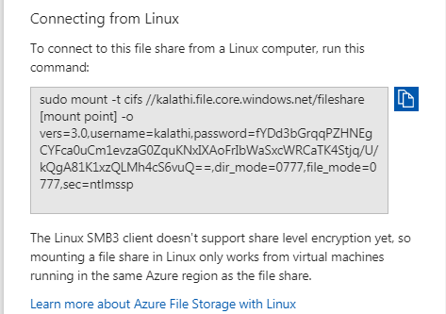

**Shared Access signature**

A shared access signature (SAS) is a string containing a security token that can be attached to the URI for an asset that allows you to delegate access to specific storage objects and to specify constraints such as permissions and the date/time range of access. This feature has extensive capabilities

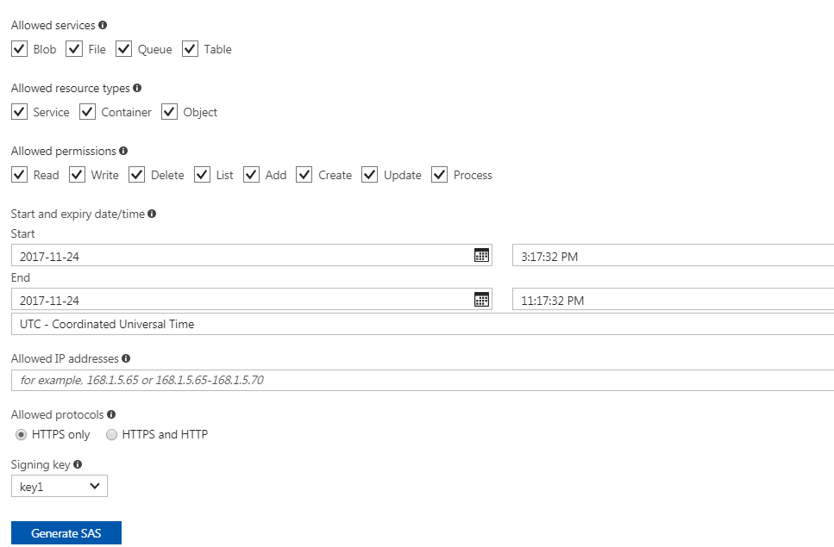

**Express Route Circuits :**

**HELP + SUPPORT + CO-ORDINATION WITH MICROSOFT**

**Support Ticket Number**: 117111317144074

**Description:**

Hi MS Team,

We could see below server got rebooted by Microsoft for Unknown Reason. Can you please check provide an update & RCA for the reboot? RG: mue2-colp-db-prod-rg VM: mue2colpdbpin02

[Problem start date and time] Mon, 13 Nov 2017 09:55:00 GMT

RCA :

As discussed over the call, please find the details of the call summary and the RCA below.

Upon our investigation on the backend logs I found many events that typically indicates that there were excessive Write IOs exceeding the IOPs limit for the Vhd mue2213502554026sa0012/vhds/datadisk005.vhd. As a workaround, I would recommend you to configure Storage Pools in order to avoid such issues in future.

In Azure for every data disk we will be having 500 IOPS limit and you many experience many read write throttles in such cases.

However, in Storage Pool concept the data disk space will be combined and you will be having only one disk with double the IOPS limit.

I would recommend you to raise another SR to Performance team where they will assist you more regarding the performance and latency issue.

Please find the below article that explains more on the storage performance.

https://blogs.msdn.microsoft.com/mast/2014/10/14/configuring-azure-virtual-machines-for-optimal-storage-performance/<https://na01.safelinks.protection.outlook.com/?url=https%3A%2F%2Fblogs.msdn.microsoft.com%2Fmast%2F2014%2F10%2F14%2Fconfiguring-azure-virtual-machines-for-optimal-storage-performance%2F&data=02%7C01%7Cv-apdevi%40microsoft.com%7Cd1b4ee8c98ad483d8c2e08d4a464c442%7C72f988bf86f141af91ab2d7cd011db47%7C1%7C0%7C636314200087895761&sdata=BYFrDZayTcEmGHxcInWifkbjpDg5cSto4dxAYRQVzgg%3D&reserved=0>

Please feel free to reach me in case you have any other queries on the issue.

And also let me know in case if the case is good for closure.

Looking forward to hearing from you.

**How to Deploy the ARM resource model using JSON template ?**

{

"$schema": "http://schema.management.azure.com/schemas/2015-01-01/deploymentTemplate.json#",

"contentVersion": "1.0.0.0",

"parameters": {

},

"variables": {

},

"resources": [

{

"name": "[concat('storage', uniqueString(resourceGroup().id))]",

"type": "Microsoft.Storage/storageAccounts",

"apiVersion": "2016-01-01",

"sku": {

"name": "Standard_LRS"

},

"kind": "Storage",

"location": "South Central US",

"tags": {},

"properties": {}

}

],

"outputs": { }

}

azgroupcreate --nameexamplegroup --location"South Central US"

azgroupdeploymentcreate --resource-groupexamplegroup --template-fileazuredeploy.json

Virtual Machine Sizes and Types

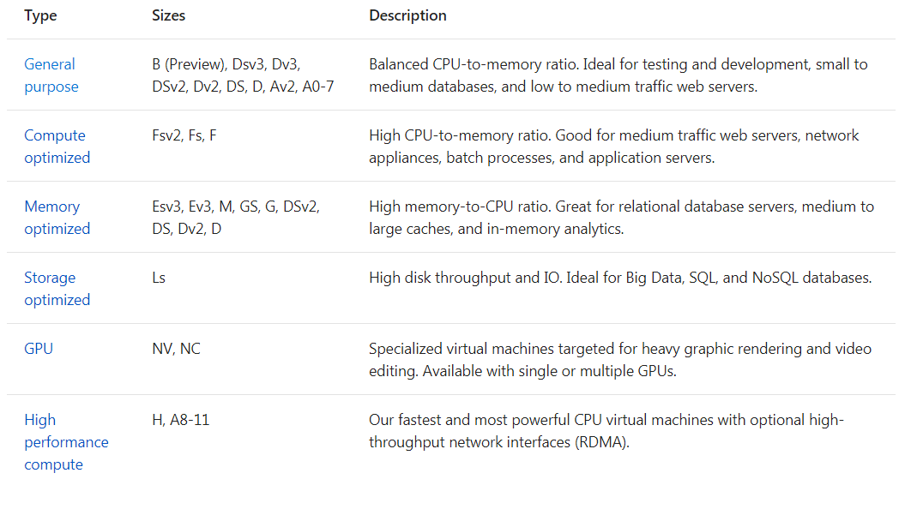

Standard DS1 v2 (1 vcpu, 3.5 GB memory)

**Standard DS2 v2 (2 vcpus, 7 GB memory)**

**Standard DS3 v2 (4 vcpus, 14 GB memory)**

**Standard DS4 v2 (8 vcpus, 28 GB memory)**

**Azure Computing unit**

We have created the concept of the Azure Compute Unit (ACU) to provide a way of comparing compute (CPU) performance across Azure SKUs. This will help you easily identify which SKU is most likely to satisfy your performance needs. ACU is currently standardized on a Small (Standard_A1) VM being 100 and all other SKUs then represent approximately how much faster that SKU can run a standard benchmark.

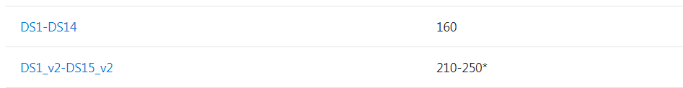

**Azure Content delivery Network**

The Microsoft Azure Content Delivery Network (CDN) offers developers a global solution for delivering high-bandwidth content that is hosted in Azure or any other location. Using the CDN, you can cache publicly available objects loaded from Azure blob storage, a web application, virtual machine, application folder, or other HTTP/HTTPS location. The CDN cache can be held at strategic locations to provide maximum bandwidth for delivering content to users. The CDN is typically used for delivering static content such as images, style sheets, documents, files, client-side scripts, and HTML pages

